Lab experiment

2.Identify the system calls to copy the content of one file to another and illustrate the same using a C program.

Aim:
To identify and use the appropriate system calls to copy the contents of one file into another file using a C program.

Algorithm:

Include necessary headers:
Include the necessary header files like <stdio.h>, <fcntl.h>, and <unistd.h> for working with file-related system calls.
Declare variables:
Declare variablesto hold file descriptors, buffer, and other necessary information.
Open the source and destination files:
Use the open system call to open the source and destination files,obtaining file descriptors for each.
Read from the source file:
Use the read system call to read data from the source file into abuffer.
Write to the destination file:
Use the write system call to write the data read from the source fileinto the destination file.
Close the files:
Use the close system call to close the source and destination files.

Coding:

#include <stdio.h>
#include <stdlib.h>
#include <fcntl.h>
#include <unistd.h>

int main()
{
int source, destination; char buffer[100]; ssize_t bytes;

source = open("source.txt", O_RDONLY);

if (source < 0)
{
perror("Error opening source file"); return 1;
}

destination = open("destination.txt",
O_WRONLY | O_CREAT | O_TRUNC,
0644);

if (destination < 0)
{
perror("Error opening destination file"); close(source); return 1;
}

printf("File copy program\n");

while ((bytes = read(source, buffer, sizeof(buffer))) > 0)
{
ssize_t total = 0;

while (total < bytes)
{
ssize_t written = write(destination, buffer + total, bytes - total);
if (written < 0)
{ perror("Error writing file"); close(source); close(destination); return 1;
}
total += written;
}
}

if (bytes < 0)
{
perror("Error reading file"); close(source); close(destination); return 1;
}

close(source); close(destination);

printf("File copied successfully\n");

return 0;
}

Output:

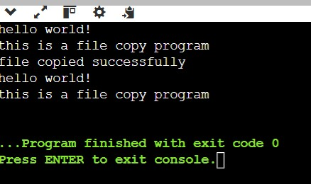

Result:
Thus, the contents of one file were successfully copied to another file using the open(), read(), write(), and close() system calls in C.

